**Assignment -1**

Python Flask

|  |  |
| --- | --- |
| Assignment Date | 19 September 2022 |
| Student Name | DEVANAND V |
| Student Roll Number | 7376191CS151 |
| Maximum Marks | 2 Marks |

**Question:**

1. Create registration page in html with username, email and phone number and by using POST method display it in next html page.

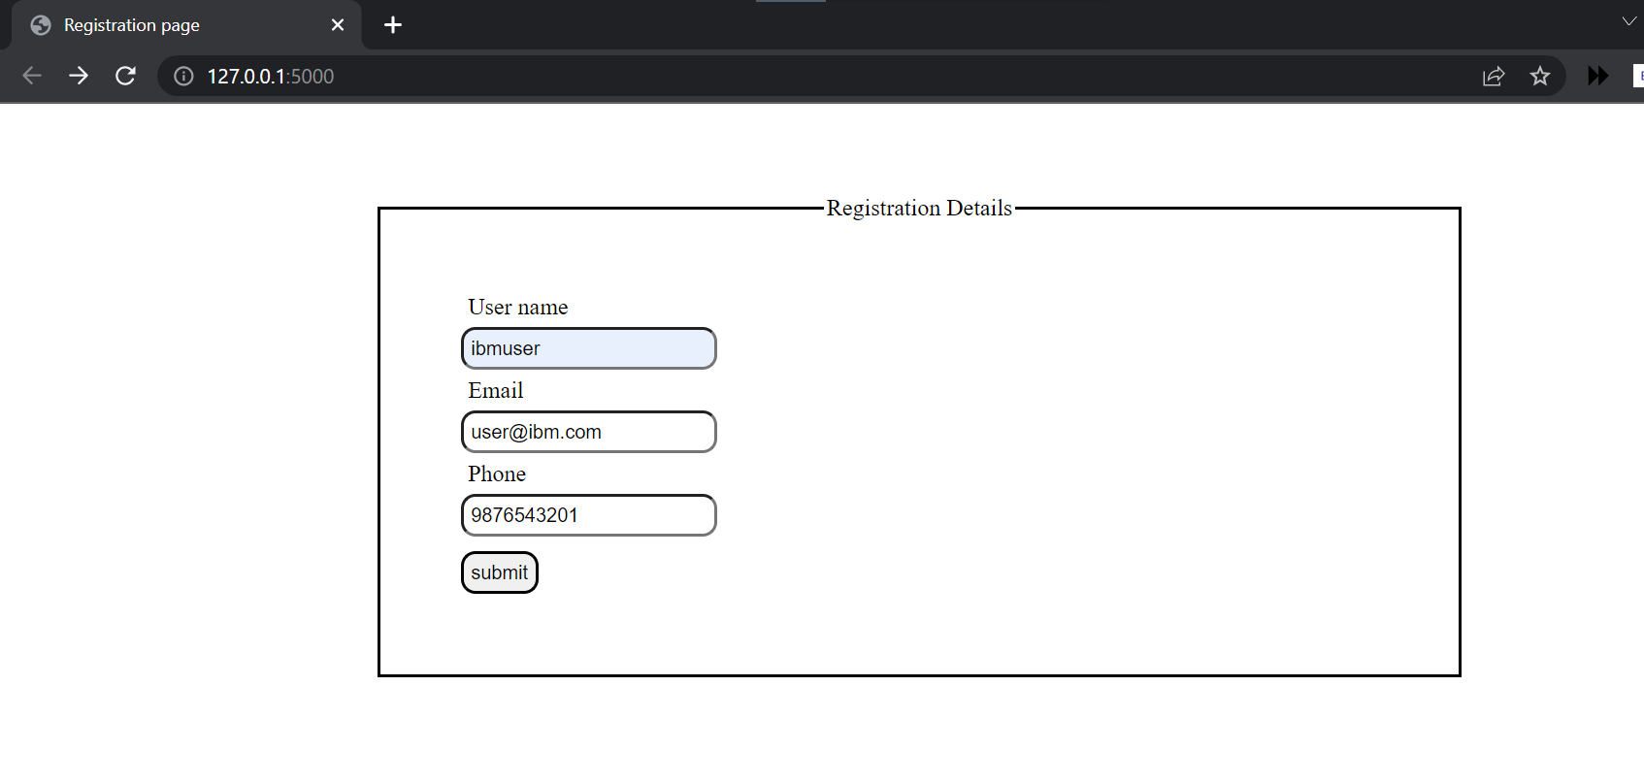

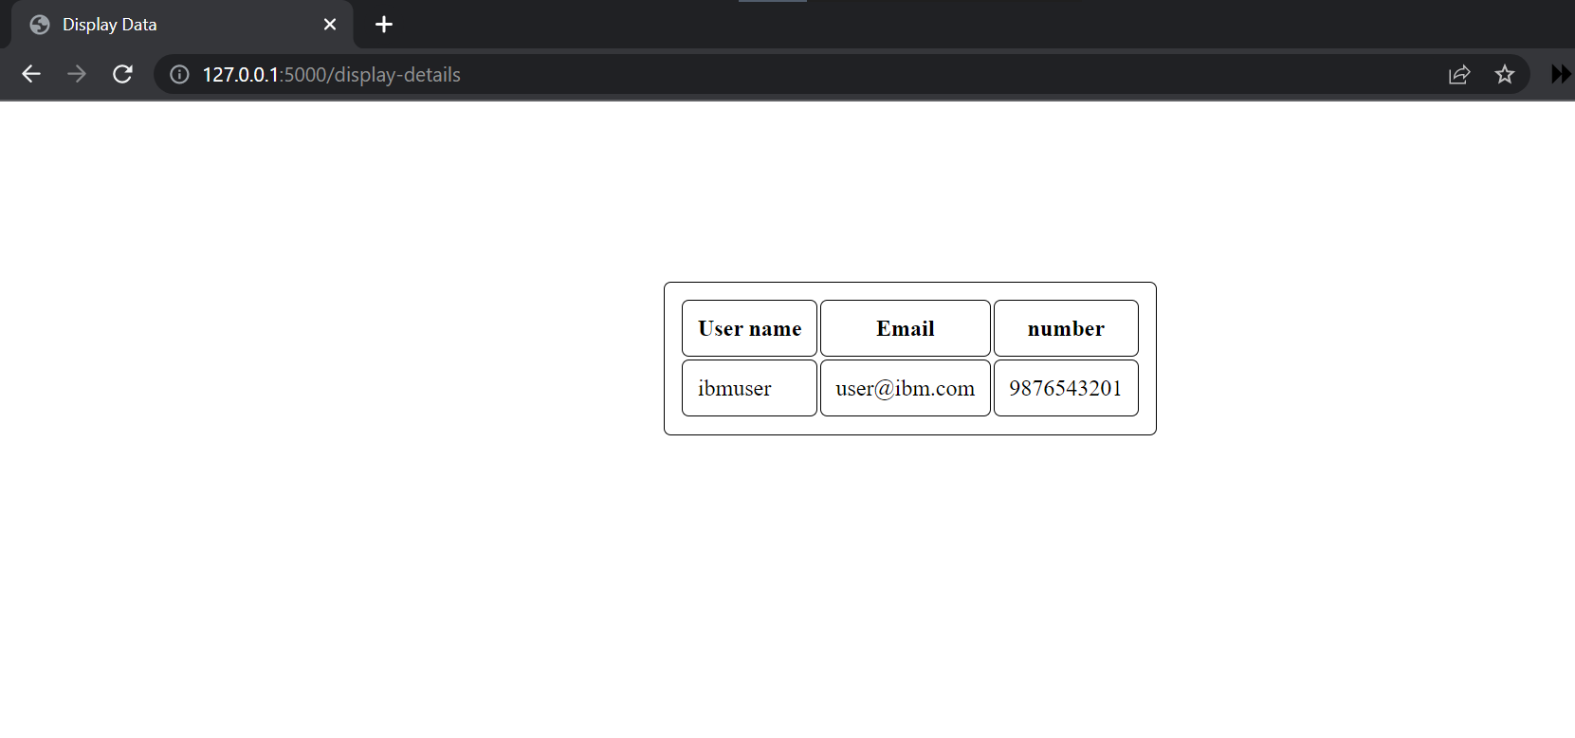

2. Develop a flask program which should contain at least 5 packages used from pypi.org.

**app.py:**

from flask import Flask

import flask_appbuilder

import flask_bootstrap

import flask_authorize

import flask_login

import flask_security

app = Flask(__name__)

@app.route('/')

def home():

    return "Hello world!";

if __name__ =='__main__':

    app.run(debug = True)